**FORM A**

**Exhibitor/Exhibits Details**

**Souvenir Entries**

The Souvenir will be distributed during the Visitors/ Exhibitors/ delegates. Please provide the following information about your company, to be published free-of-charge in alphabetical listing of companies in the Souvenir of EWCI 2018. Entries are subject to editing at the organiser’s discretion.

Booth No: ____________________

Company Name : ___________________________________________________________________

Full Address : ___________________________________________________________________

: ___________________________________________________________________

Telephone No. : ___________________________________________________________________

Fax Nos. : ___________________________________________________________________

E-mail : ___________________________________________________________________

Contact Person : ___________________________________________________________________

With Designation __________________________________________________________________

**Products to be displayed in the Exhibition (please give full details of products, if necessary, attach a separate sheet)**

1. _______________________________________________________________________________
2. _______________________________________________________________________________
3. _______________________________________________________________________________
4. _______________________________________________________________________________

**Please give the name(s) of Foreign Collaborators/ Associate Companies, whose products you plan to display at the exhibition, along with product details, Address, Telephone and fax Numbers, Contact Person’s name, logo etc.**

1. _______________________________________________________________________________
2. _______________________________________________________________________________
3. _______________________________________________________________________________

**In case of a Foreign Exhibitor, please give name (s) of Indian Associates/ Distributors/ Dealers/ Representatives along with Address, Telephone/ Fax Numbers and E-mail address.**

1. _______________________________________________________________________________
2. _______________________________________________________________________________
3. _______________________________________________________________________________

**Please enclose Brief Company Profile (not more than 100 words)**

Signature : ________________ Date: ___________________________________

Designation: ________________ Company’s Stamp: ________________________

**Deadline: 10 January2018.** Please send email to [**ewci@aoc-india.org**](mailto:ewci@aoc-india.org)or Fax to +91 80 2528 7813

**FORM B**

**Details for Facia**

Please give below (in caps) name of your company, the way you would like to appear, on the Facia of your stand.

|  |  |  |  |  |  |  |  |  |  |  |
| --- | --- | --- | --- | --- | --- | --- | --- | --- | --- | --- |
|  |  |  |  |  |  |  |  |  |  |  |

|  |  |  |  |  |  |  |  |  |  |  |
| --- | --- | --- | --- | --- | --- | --- | --- | --- | --- | --- |
|  |  |  |  |  |  |  |  |  |  |  |

|  |  |  |  |  |  |  |  |  |  |  |
| --- | --- | --- | --- | --- | --- | --- | --- | --- | --- | --- |
|  |  |  |  |  |  |  |  |  |  |  |

|  |  |  |  |  |  |  |  |  |  |  |
| --- | --- | --- | --- | --- | --- | --- | --- | --- | --- | --- |
|  |  |  |  |  |  |  |  |  |  |  |

|  |  |  |  |  |  |  |  |  |  |  |
| --- | --- | --- | --- | --- | --- | --- | --- | --- | --- | --- |
|  |  |  |  |  |  |  |  |  |  |  |

|  |  |  |  |  |  |  |  |  |  |  |
| --- | --- | --- | --- | --- | --- | --- | --- | --- | --- | --- |
|  |  |  |  |  |  |  |  |  |  |  |

* Indian companies cannot give the names of their foreign principals (conditions Apply)

**Deadline: 10 January 2018.** Please send email to [ewci@aoc-india.org](mailto:ewci@aoc-india.org) or Fax to +91 80 2528 7813

**FORM C**

**Exhibitor Badges**

Please give names of the representatives who would be attending your Booth for Exhibitor Badges.

Only **two** names per Booth (size of 3 m x 3 m) to be provided.

Exhibitor: __________________________________ Booth No: ______________________

Exhibitor: __________________________________ Booth No: ______________________

Contact Person: ______________________________ Signature: ______________________

The organisers reserve the right not to issue Exhibitor Badges to those who have no connections to the exhibiting company.

**Deadline: 10 January 2018.** Please send email to [ewci@aoc-india.org](mailto:ewci@aoc-india.org) or Fax to +91 80 2528 7813

**FORM D**

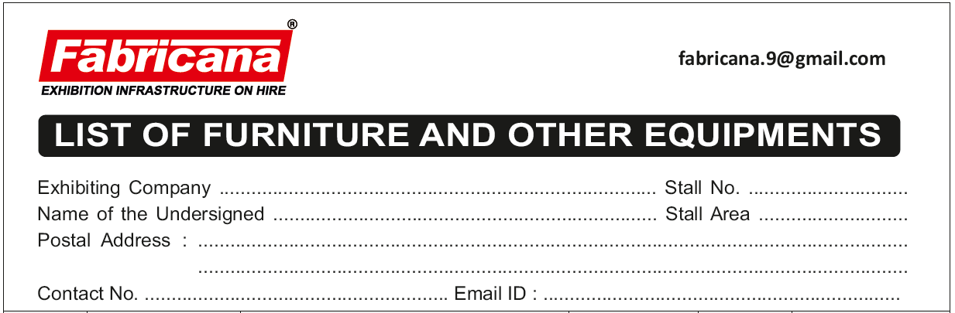**Order form for Additional Facilities (Highlight the required item)**

**Deadline: 1 Feb 2018.** Please send email to [Fabricana.9@gmail.com](mailto:Fabricana.9@gmail.com) or contact:

**M/s. Fabricana**, #30, J.C Industrial Layout, Yelachenahalli 2nd Phase, Kanakapura Road, Bengaluru - 560 062

Telephone: +91-80-26545466/88/99, 26650739, Fax: +91-80-26645631, Mobile: 9845173614

**FORM E**

**For Glass Room Booking**

Exhibitor: _______________________________________________________________________________

Booth No.: ____________________________________

Telephone : ____________________________________ Fax: ____________________________

Contact Person’s Name: ______________________________________________________________________

Glass Room required on ______________________ (Date), from _____________ Hrs to _______________Hrs

**Maximum of 45 min per Sponsor on two occasions**

**Deadline: 1 Feb 2018.** Please send email to [ewci@aoc-india.org](mailto:ewci@aoc-india.org) or fax to +91 80 2528 7813